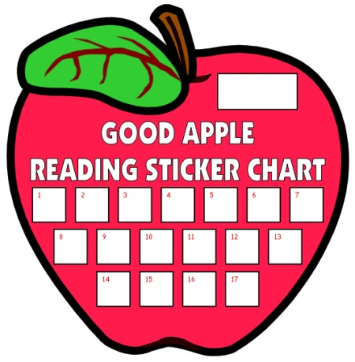

Rm. #:

Teacher’s Name: